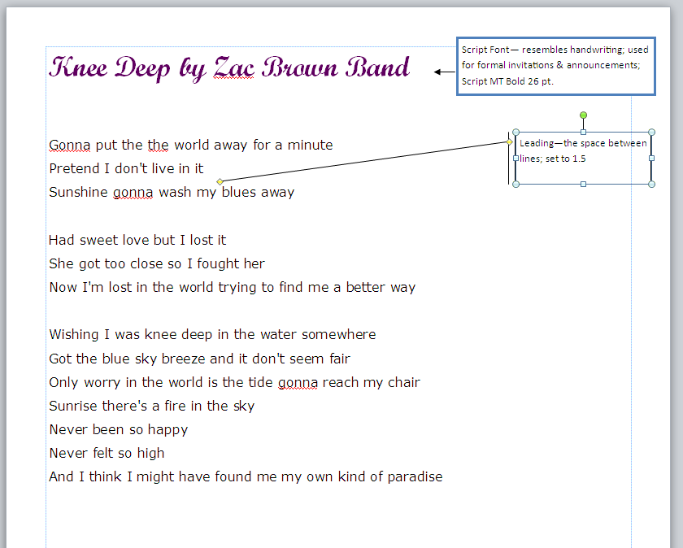
Directions:
- Using the Internet, look up the lyrics to your favorite song or lines of your favorite poem. The song or poem’s content must be appropriate for school.
- Paste the lines into a blank Microsoft Word or Publisher document.
- Change the text throughout the song or poem to demonstrate a correct understanding of the following terms:
- Serif
- Sans Serif
- Script
- Ornamental
- Leading
- Kerning
- Tracking
- Monospaced
- Proportional
- Label the use of each of the following terms above. (Tip: Insert text boxes with arrows.)
- You will be graded based on the following rubric:
Task | Points Awarded
All typography terms are correctly demonstrated 45 pts. (5 pts. Per term)
Comments correctly identify & define the term 45 pts.
(5 pts. Per term)
Comments correctly identify the font type used 5 pts.
Content is one page 5 pts.
Total/Comments:

