Scratch: Break Dancer
Follow the instructions to make the break dancer dance in Scratch
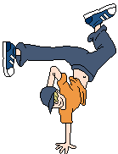 | - This tutorial allows you to make the break dancer dance to music playing in the background.

Task 1: Dance Moves
- Click the cat and then click 'delete' | 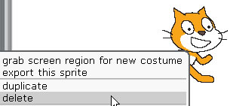
- Click ‘Choose new sprite from file’ | 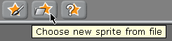
- Double click the ‘People’ folder
- Click on ‘breakdancer-2’ | 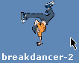
- Click ok.
- The sprite will now appear on the stage.

- Add the blocks as shown. | 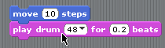
- Add in the same blocks again (as shown) | 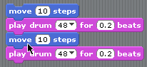
- Change the second ‘move’ block to -10. | 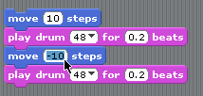
- Change the second drum to a different sound. | 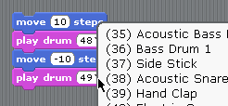
- Add the control blocks as shown. | 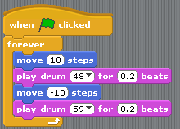
- Click the ‘green flag’ and check out your break dancer!
- Experiment with changing the drums and the ‘beat’ numbers.

Task 2: Changing Costumes
- Click on the ‘Costumes’ tab. | 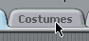
- Click ‘Import’ | 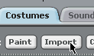
- Import breakdancer-3 and then click OK. | 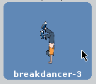
- Do the same again, but import breakdancer-4. | 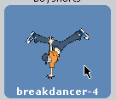
- Do the same again, but import breakdancer-1.
- Click on the ‘Scripts’ tab. | 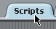
- Click on the ‘looks’ option and then add the blocks shown. | 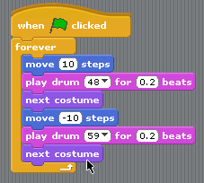
- Press the green flag to test your script.

Task 3: Changing Backgrounds
- Click on to the ‘stage’ icon.
- Click on to the ‘Backgrounds’ tab.
- Click ‘Import’
- Double click the ‘Indoors’ folder.
- Click the spotlight-stage background | 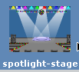
- Click ‘ok’.
- Click and drag the breakdancer sprite so it’s on the stage.

Task 4: Looping Music
- Click on to the dancer | 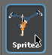
- Change the blocks as shown: | 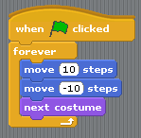
- Add the ‘wait’ blocks and change the number to 0.5. | 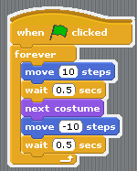
- Click on the ‘Sounds’ tab. | 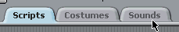
- Click ‘Import’ | 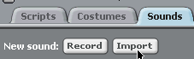
- Double click the ‘Music Loops’ folder
- Click ‘HipHop’ and then click OK. | 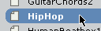
- Add the second set of blocks as shown and then test it out. | 