1.02 Design an Infographic
Step 1: Choose a Topic
Using the internet, collect data or information about a growing community, school, or global concern. You may wish to review some of the topics at the following websites:
Global Issues http://www.globalissues.org/
Educational Issues http://www.education.com/topic/current-education-issues/

Step 2: Learn More About Infographics
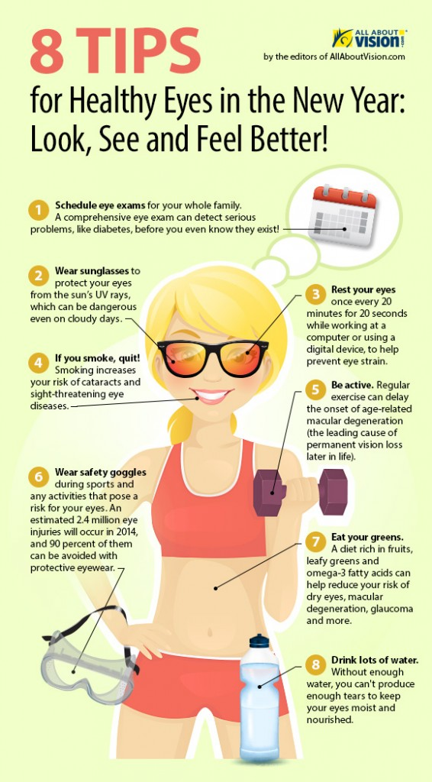
Ideas for infographic formats include:
- Timelines
- Flow charts
- Annotated maps or graphics
- Graphs
- Venn diagrams
- Size comparisons

Step 3: Design Your Infographic
Using desktop publishing software, create an 8 ½” x 11” infographic related to your topic.

